**Experiment Name:** FCFS Disk Scheduling algorithm.

**Experiment No:** 04

**Objectives:** In this lab we will Learn about FCFS Disk Scheduling Algorithm and Implement of FCFS Disk Scheduling algorithm by using c program.

First Come First Serve (FCFS)

1. Requests are serviced in the order in which they arrive
2. The algorithm is easy to implement
3. Bad algorithm as it may involve lots of unnecessary seek distance

**CODE:**

#include<stdio.h>

void main()

{

int queue[20],n,head,i,j,k,seek=0,max,diff;

float aver;

printf("enter the max range of disk");

scanf("%d",&max);

printf("enter the size of queue request");

scanf("%d",&n);

printf("enter the queue");

for(i=1; i<=n; i++)

{

scanf("%d",&queue[i]);

}

printf("enter the initial head position");

scanf("%d",&head);

queue[0]=head;

for(j=0; j<=n-1; j++)

{

diff=abs(queue[j+1]-queue[j]);

seek+=diff;

printf("move is from %d to %d with seek %d\n",queue[j],queue[j+1],diff);

}

printf("total seek time is%d\n",seek);

aver=seek/(float)n;

printf("avrage seek time is %f\n",aver);

}

**Output:**

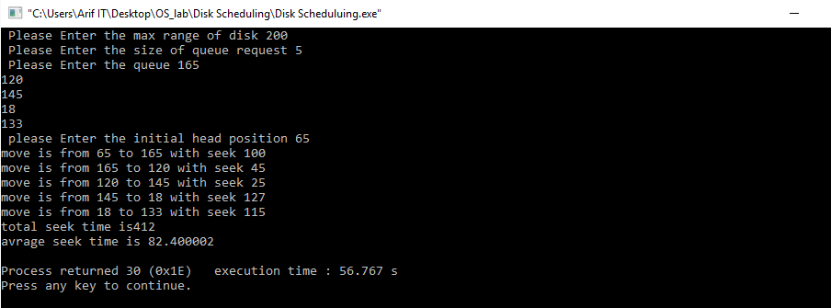

Discussion : After doing this lab we learn about the implementation of FCFS Disk Scheduling algorithm and we do the lab report successfully by using C program And testing the program